- Abstract
- Introduction
  - More for pufa or temperature or both?
  - Main focus: cold adaptation
  - Mention pufas too as a relevant biological thing
- Materials and Methods

From Serina: Looking great so far! In general, I just changed details (see comments). Overall don’t worry about putting in the references right now. If you’re running short on time those can always be added in later (even this fall). Priority is getting the results down in writing while they’re fresh in your mind. If you have time (e.g. after you’ve got a results draft) I would consider breaking the methods and results up into sub-headings like ‘Machine learning,’ ‘Phylogenetics’ etc. to break up the text a bit. Nice job, I know you’ve been working hard!

Literature was searched to acquire optimum growth temperature and isolation information for the 20 psychrophiles and thermophiles from which oleAs were ordered. Optimal growth temperature was also found for many of the 73 organisms with oleAs from previous experiments in the Wackett lab.
The Xanthamonas campestris oleABCD genes and the pfaA gene from Shewanella oneidensis were blasted against the genomes of the 20 psychrophiles and thermophiles. Hits with greater than 25% identity and 75% query cover were kept for analysis. Phylogenetic trees were built with MEGA X software using (alignment type), the maximum-likelihood method, and 500 bootstraps. The gene diagram was formed from the blast hits described earlier, localized on the oleA and removing any relevant genes farther than 10,000 bp away.
Global protein properties like hydrophobicity, instability index, and isoelectric point were calculated in R using the Peptides package (include reference to sheet with descriptions?). Ratios between specific residues, including specifically relevant ratios like RKrat, were calculated.
Sets of residues from specific protein features were extracted in R. These features included channels A and B from () and spheres of varying radii around the active site.
Machine learning prediction of temperature optimum was done with a random forest prediction model in R. Features with near-zero variance were removed using the nearZeroVar function from the caret package in R (). Data was split randomly with 80% going into the training set and 20% into the testing set. The models were built using the train function in the ranger package. Residue factors that were shown to be significant in the prediction were found using the varImp function of the ranger package.
Machine learning was used to predict optimal temperature using a regression line. 4 different feature sets were tested and compared: channel residues, 8 angstrom sphere, 10 angstrom sphere, and 12 angstrom sphere. Root mean squared error and r squared error were used to assess performance.
A machine learning model was also made to categorize the samples into 3 groups of different temperature ranges: equal to or less than 15 °C, greater than 15 °C and less than 30 °C, and equal to or greater than 30 °C. Percent accuracy of the training cross validation and percent accuracy for the prediction of the testing set as well as standard deviation for each set were used to assess performance.

  - Lit searching
  - Searched for pufa genes
  - Made gene diagrams/phylogenetic trees
    - Mega info
    - Define what a “hit” is for diagram (75/20)
  - Calculated global protein properties and protein ratios
    - Example in robinson journal article in writeup (reference supp. table in that)
  - Did machine learning with global properties
    - Random forest
    - Also examples in that paper
  - Extracted residues from specific feature sets
  - Did machine learning with feature sets (categorical and regression) to predict optimal temperature
  - Results: at important residues for prediction and formed possible experiments using mutant library and others
- Results
The dataset includes 30 OleAs from genomes acquired in the TARA Oceans expedition, 20 OleAs from psychrophiles and thermophiles isolated from extreme conditions, and 73 OleAs used in previous experiments in the Wackett lab ().
  - Introduce dataset (multipanel figure and supplemental table)
    - Over 200 olea-type clusters and picked taxonomically diverse strains
  - Tree/diagram
  - Heatmap (supp?) worth mentioning RKrat
  - Machine learning stuff
  - Tables with feature sets
  - Important residues
- Future directions/planned experiments
  - Kocuria funny business
  - Mutant library screening for important channel residues
  - Activity assays?
- Figures
  - Figures describing dataset
    - 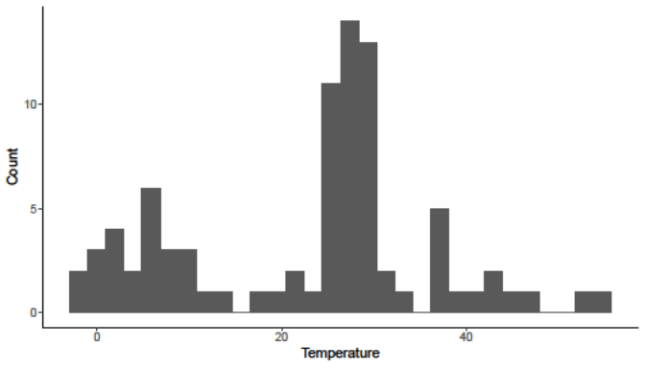
    - 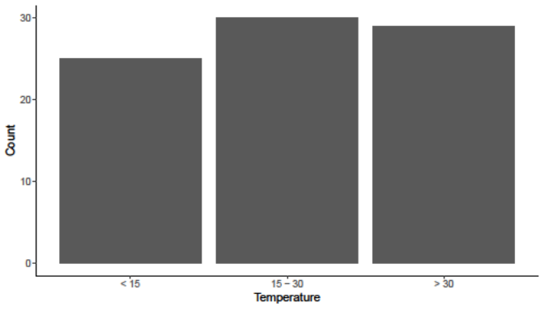
    - 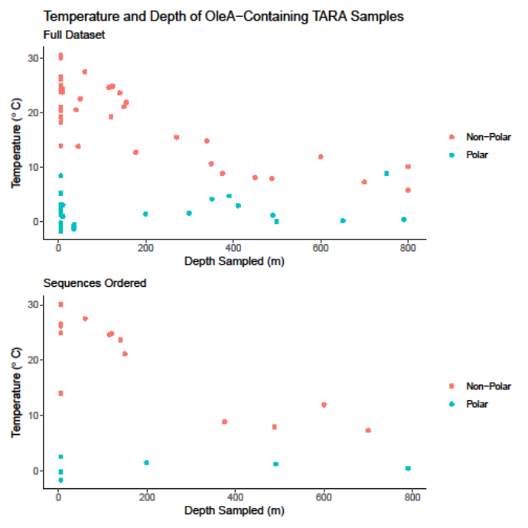
    - 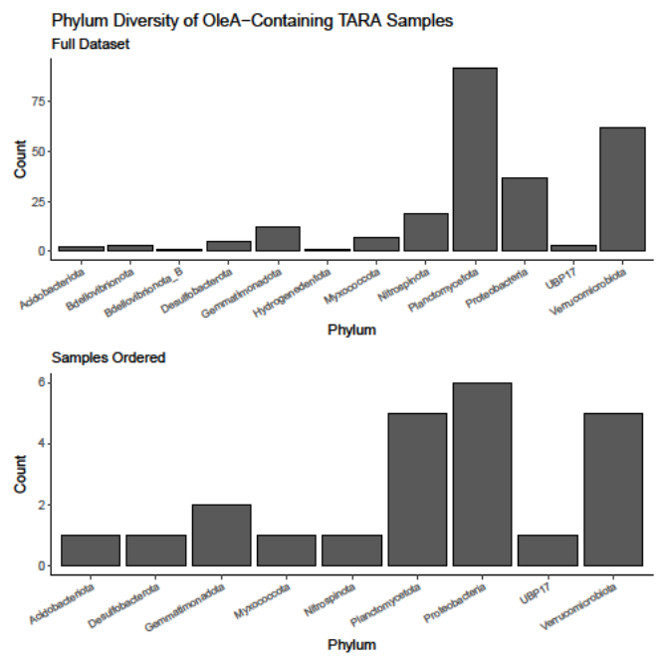
    - 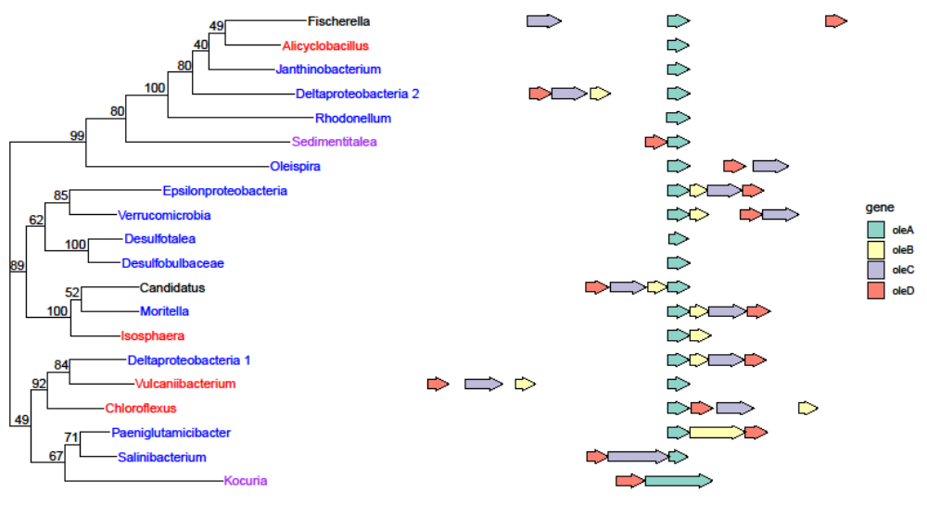
  - Feature analysis
    - Channel logo A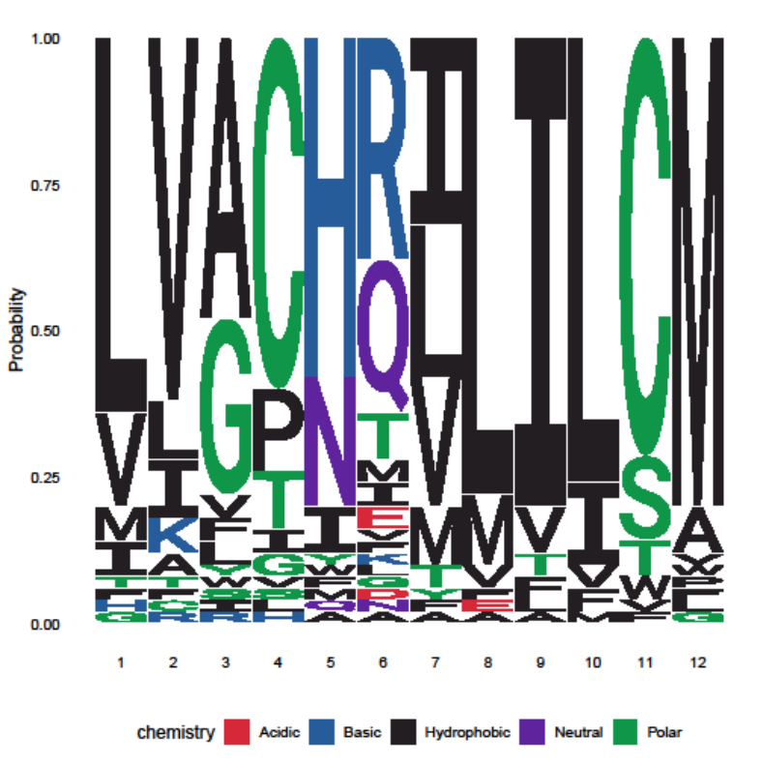
    - Channel logo B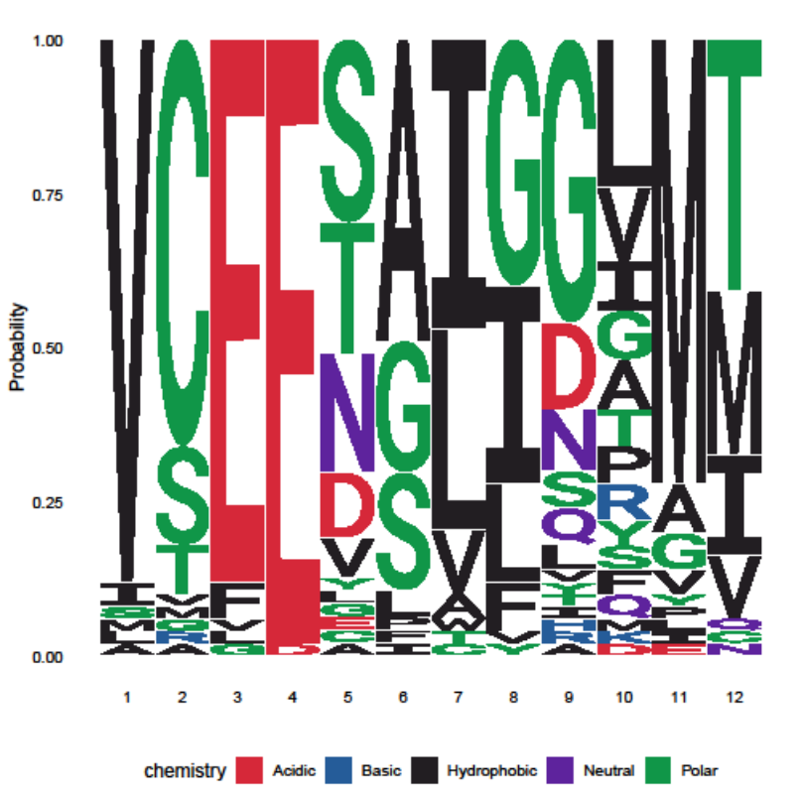
    - There are more of these 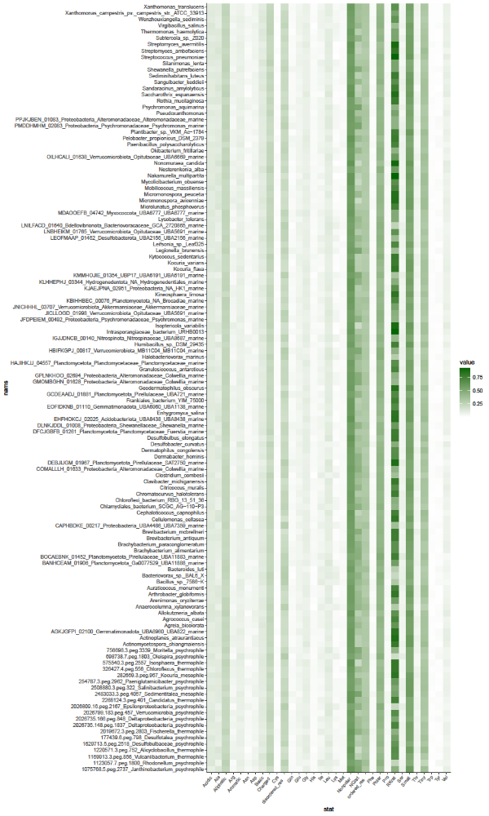
    - 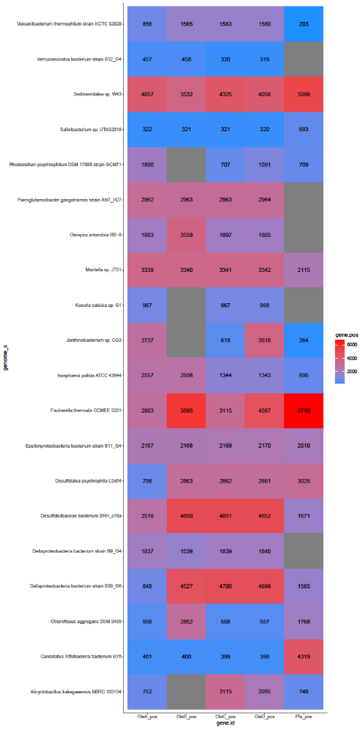
  - Machine learning
    - 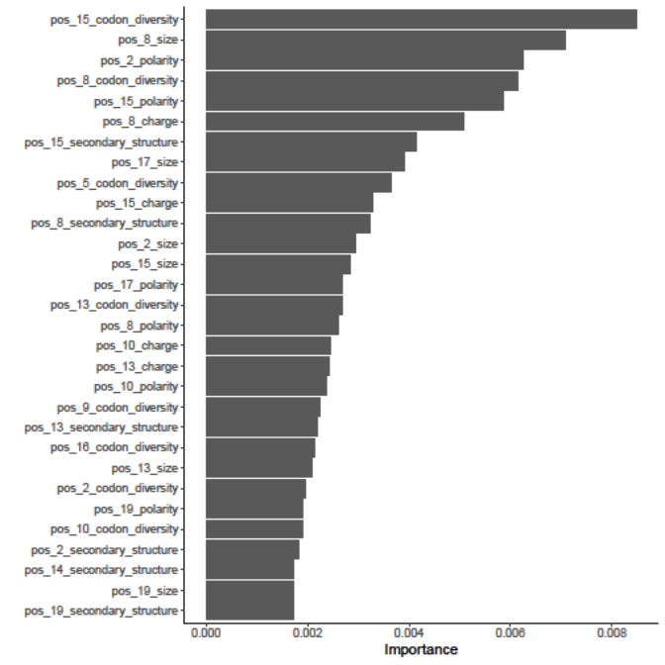
    - Logo of important residues in channel for temperature prediction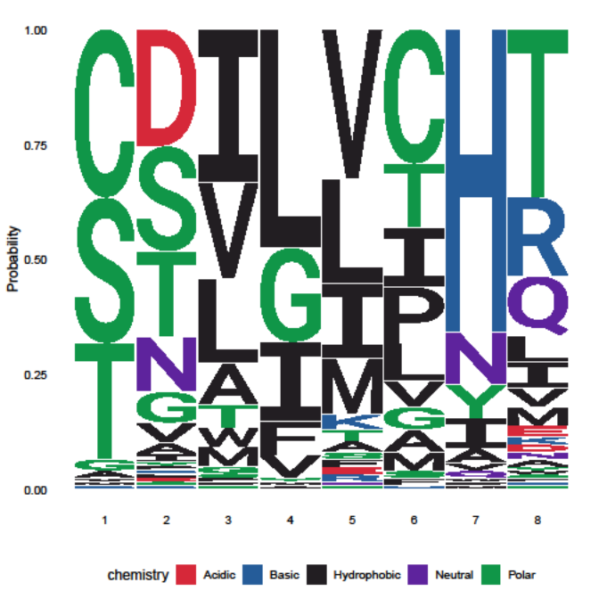
    - Example temperature prediction plot